DCA Note:
This document is a list of various Medici.tv performances that are Christmas themed or related in some way.
Please feel free to use any part of this doc, and edit it in any way you like, to create social media posts.

For example, you could pick 3-4 of your favourites from this list, and create a social media post about each - use the images and copy provided, or feel free to tweak it!

You could also tidy up this document and post the whole list for your customers. We recommend switching the links to the specific links for your library’s Medici login, which will make it easier for your customers to find the right video. To do this:

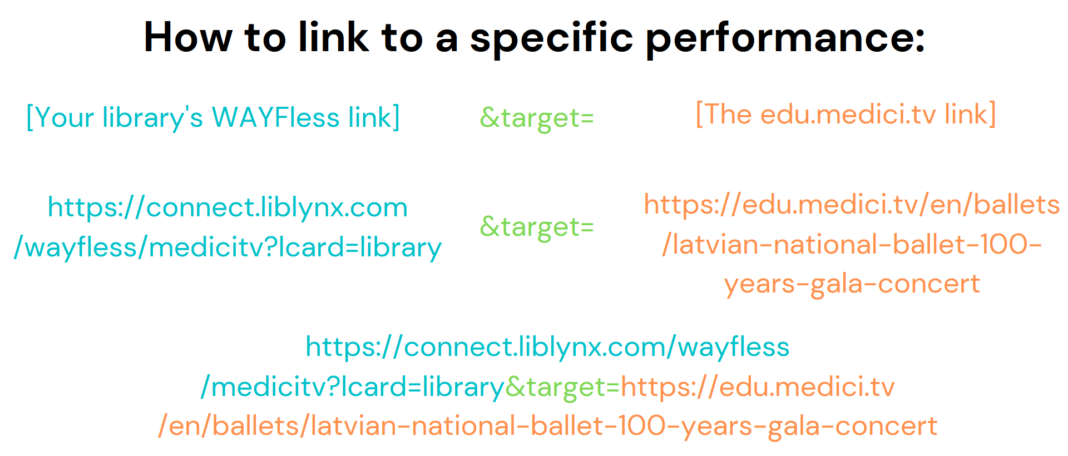

Have a classic Christmas with Medici TV

CONCERTS

The Three Tenors Luciano Pavarotti, Plácido Domingo, and José Carreras sing Christmas Music

Wiener Symphoniker

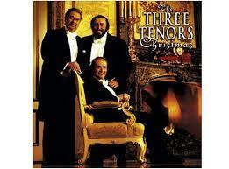

On December 23, 1999, Vienna’s opulent Konzerthaus played host to a remarkable event: a Christmas concert featuring the three tenors—Luciano Pavarotti, Plácido Domingo, and José Carreras—singing a mix of sacred and popular Christmas songs. From Irving Berlin’s White Christmas to Johannes Brahms’s Wiegenlied: Guten Abend, gute Nacht, from Adeste Fideles to Feliz Navidad, three of the most popular singers of the late 20th century gave heartwarming performances accompanied by the Vienna Symphony Orchestra and the Gumpoldskirchner Spatzen Children’s Choir. A sure-fire winner to kindle the Christmas spirit!

Veni Domine – Christmas at the Sistine Chapel

Sistine Chapel Choir

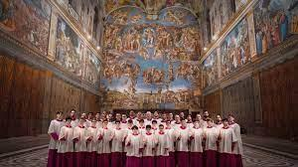

Join the talented young singers of the acclaimed Sistine Chapel choir—one of the oldest choirs in the world!—for an enthralling concert of Advent and Christmas-themed polyphonic chefs-d'œuvre from the Vatican Library’s vault! Filmed in the legendary architectural and artistic masterpiece of a room that gave the choir its name, highlights from the performance include never-before-recorded works by Renaissance masters like Giovanni Pierluigi da Palestrina, Guillaume Dufay, and Gregorio Allegri. A truly out-of-the-ordinary Christmas celebration in a stunning setting.

Bach's Christmas Oratorio
One of the true treasures of the sacred choral repertoire.
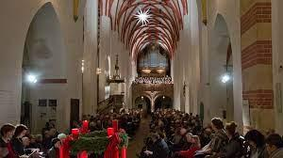
It was in 1734 in Leipzig’s St. Thomas Church where the Oratorio—made up of six cantatas composed for the major feast days of the Lutheran Christmas calendar—was first performed, and it is in the same church that Gotthold Schwarz, the seventeenth Thomaskantor (St. Thomas Church music director) since Bach’s own tenure, brings the masterpiece once more to life with his elite boy’s choir.

Philippe Herreweghe conducts Bach's Christmas Cantatas

Collegium Vocale Gent

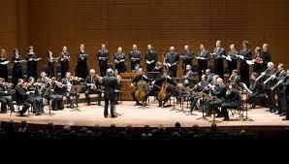

If you can’t get enough Bach, then sit back and enjoy Philippe Herreweghe, the Collegium Vocale Gent, and its period-instrument orchestra in a concert filmed on December 23, 2015 at Paris’s beautiful Église Saint-Roch! Joined by soprano Dorothee Mields, countertenor Damien Guillon, tenor Thomas Hobbs, and bass Peter Kooij, they perform four seasonal cantatas from J.S. Bach’s time in Halle and Leipzig.

Gloria in Excelsis Deo: A Christmas Concert by Thomas Clamor and the Sächsische Bläserphilharmonie – With Ruth Ziesak
Christmas in the Erzgebirge region is one of Saxony’s most treasured traditions. Its unique celebrations include numerous customs focusing on music. In this film it is the setting for a concert of classical and seasonal works performed by an exquisite ensemble of wind instruments and Germany’s leading youth choir. In addition the prominent soprano Ruth Ziesak performs, in a program featuring seasonal Handel, Schuman, Wagner, Mendelssohn and Tchaikovsky among others.
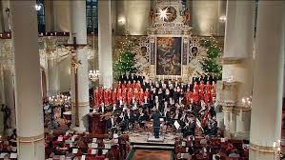

DOCUMENTARY

Silent Night: The Songs of Christmas

God's Greatest Hits (VI/XI)

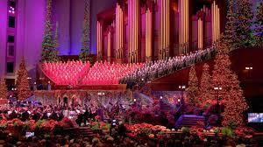
Silent Night is easily one of the best-known Christmas songs. In this episode we hear it along with several other favourite seasonal songs performed by The Bills, The Sojourners, Tony McManus & Suzie Vinnick, and The Nathaniel Dett Chorale.
‘God's Greatest Hits’ is a Canadian documentary series that explores the history of some of the best-known spirituals in the world. From Christian hymns to gospel songs, each episode presents information from historical archives and features interviews with music critics, musicians and scholars.

BALLET
The Nutcracker
As much a Christmas staple as mincepies and tinsel, The Nutracker has been timelessly enchanting audiences since 1892. Binge-watch this sumptuous ballet on Medici, with five very different premium performances from some of the world’s leading companies.
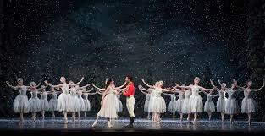
You would be hard-pressed to find a more dazzling production than this pristine 2018 recording from the Royal Ballet at Covent Garden.
If you like your nutcracker with a twist, try this performance from the Dutch National Ballet, which is set in the early 19th century during the feat of Saint Nicholas. A magical moment when Clara’s living room transforms into a snowy forest and sends dancers skating down frozen Dutch canals!
Or try the Nutcracker Sweeties, from The Birmingham Royal Ballet with music by Billy Strayhorn and Duke Ellington a 35 minute big-band take on the ballet as you have never seen or heard it before! It portrays Broadway and American in the 1940s: full of humour, irony, swing and blues. Dressed in an array of glamorous Jasper Conran costumes, the cast includes drum majorettes, sailors, pom-pom girls, GIs and Candy Kane. Fl;ashing neon sets and jazz-style choregography make this an imaginative, funny and visually irresistible short.
For fans of the original tale, The Nutcracker and the Mouse King (2018) by visionary choreographer Christian Spuck plunges more deeply than most versions into the 1816 text by master of the macabre, E.T.A. Hoffman. Both romantic and fantastic, bordering on the sublime and absurd, the corps de ballet of Ballett Zurich dance to an adapted score.
The US’s most revived staging of The Nutcracker originated from the New York City Ballet’s legendary director and choreographer George Balanchine (1954), incorporating more child dancers than ever before. In December 2011, film maker Alan Skog and the New York City Ballet produced a truly compelling performance of Balanchine’s classic choreography, earning an Emmy nomination in the process. (1h 39 min)
Alice’s Adventures in Wonderland
A ballet by Christopher Wheeldon highlighted in Medici’s Classical Music for Children playlist, performed here by The Royal Ballet in 2017. This three-act ballet accentuates the fantastical and cinematic elements of the original story, keeping Lewis Carroll’s enigmatic and fanciful spirit at its centre. Brilliant sets and costumes are inspired by the original illustrations, brought to life by an array of excellent performances including the powerful Laura Morera portraying the hysterical Queen of Hearts.
Swan Lake
One of the most lush and beautiful scores ever written accompanies perhaps the most beloved ballet of all-time. Premiered by the Bolshoi Ballet in 1877, this iconic ballet was adapted into the classic version as we now know it, in 1894 by Marius Petipa and Lev Ivanov, on which the great Rudolf Nureyev based his later production.

The National Ballet Theatre of Ukraine treat us to a classic version of Swan Lake, remaining true to the spirit of the original, guaranteeing emotion and enchantment amid the melodies of Tchaikovsky’s masterpiece. (2 hours, 8 minutes)
World class dancers of the Bolshoi Ballet leap and twirl in sumptuous costumes amid eye-catching sets, dazzling the audience throughout. Multi-award winning and world-renowned Svetlana Zakharova steps into the leading role of Odette and Odile, seemingly effortlessly delivering 32 fouettes in the second act – one of the most virtuosic feats in all of ballet. (2hours, 4 mins)
Sleeping Beauty
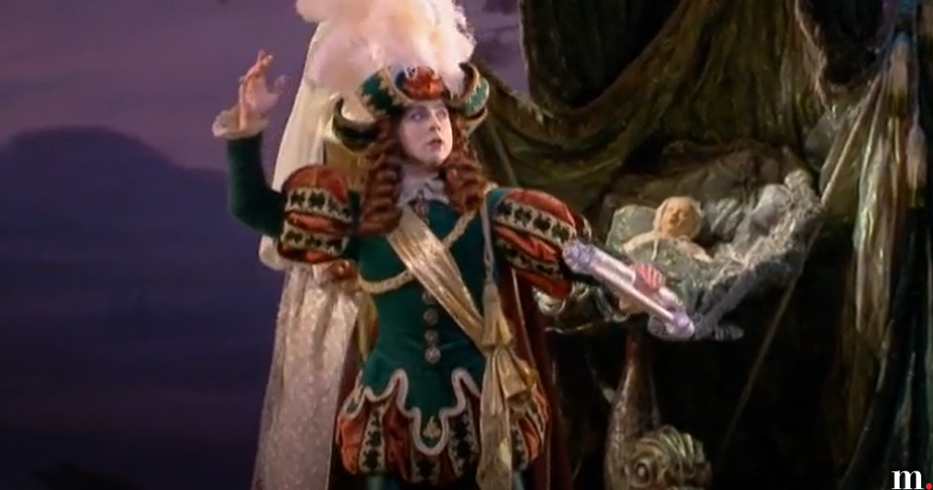
The "ever-perfect Marianela Nuñez and Vadim Muntagirov" (The Guardian) headline this immaculate Royal Ballet production of Tchaikovsky's The Sleeping Beauty, in the classic choreography by Marius Petipa!
Performed in Covent Garden, 2017: 2h 18m
Cinderella

Cinderella by Rudolf Nureyev, music by Sergei Prokofiev

Corps de Ballet de l'Opéra national de Paris

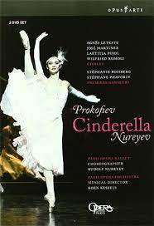

An adaptation of Charles Perrault's fairy tale by Rudolf Nureyev, with the traditional fairy character presented as a Hollywood Producer, turning the film star into a modern prince charming. In this refreshing version, Agnes Letestu as Cinderella displays her skills in tap-dance, ballroom dancing in high heels and en pointe!

Les Ballets de Monte Carlo portrays Cinderella as a natural and unaffected beauty who – with the help of her Fairy Godmother – saves the Prince from a decadent superficial lifestyle of the court. Costumes, lighting and the set affirm the fantastical and dreamlike world of the ballet, with ephemeral gold powder replacing the traditional gold slippers. Arguably one of the most moving interpretations, this performance highlights the dynamics of Prokofiev’s score.

OPERA: CINDERELLA

12-year-old Alma Deutscher’s full-length opera Cinderella is one of her greatest accomplishments to date. She started composing the opera aged just 8 and it premiered in an early chamber version in 2015 in Israel, before being performed in a fuller version in Vienna under the patronage of the great conductor Zubin Mehta.
Try this Viennese version for children from 2018, lasting just 1hr 15 minutes. This modern version of the beloved fairy tale blends humour, poetry and the magic of theatre. The title character is a young composer, envied by her stepmother and stepsisters for her talent and forced to toil away as a mere copyist. But compelled by the same love for art, Prince Charming – himself a poet in this retelling – comes to Cinderella’s aid.
Or feast your eyes and ears on this version of Deutscher’s opera . Re-orchestrated for a full chamber orchestra and performed in period costume, with spoken word as well as operatic voice, by Opera San Jose in 2017 this runs for 2 hours and 32 minutes. The opera resets the fairy tale as taking place in an opera company run by Cinderella’s evil stepmother.

Massenet’s Cendrillon was performed at Glyndebourne in 2019 with the spellbinding Danielle de Niese in the title role. Relive the enchanting musical setting of this exquisite fairy tale that includes a funny yet moving performance from Cinderella’s father as a widower too timid to stand up to his new (and gloriously over-the-top) spouse. This staging mixes décor and costumes from the composer’s era with today’s and received outstanding reviews from the nation’s critics and press.

